Data Structure and Advanced Programming

Homework 4

**第一題**

1. Paired parentheses

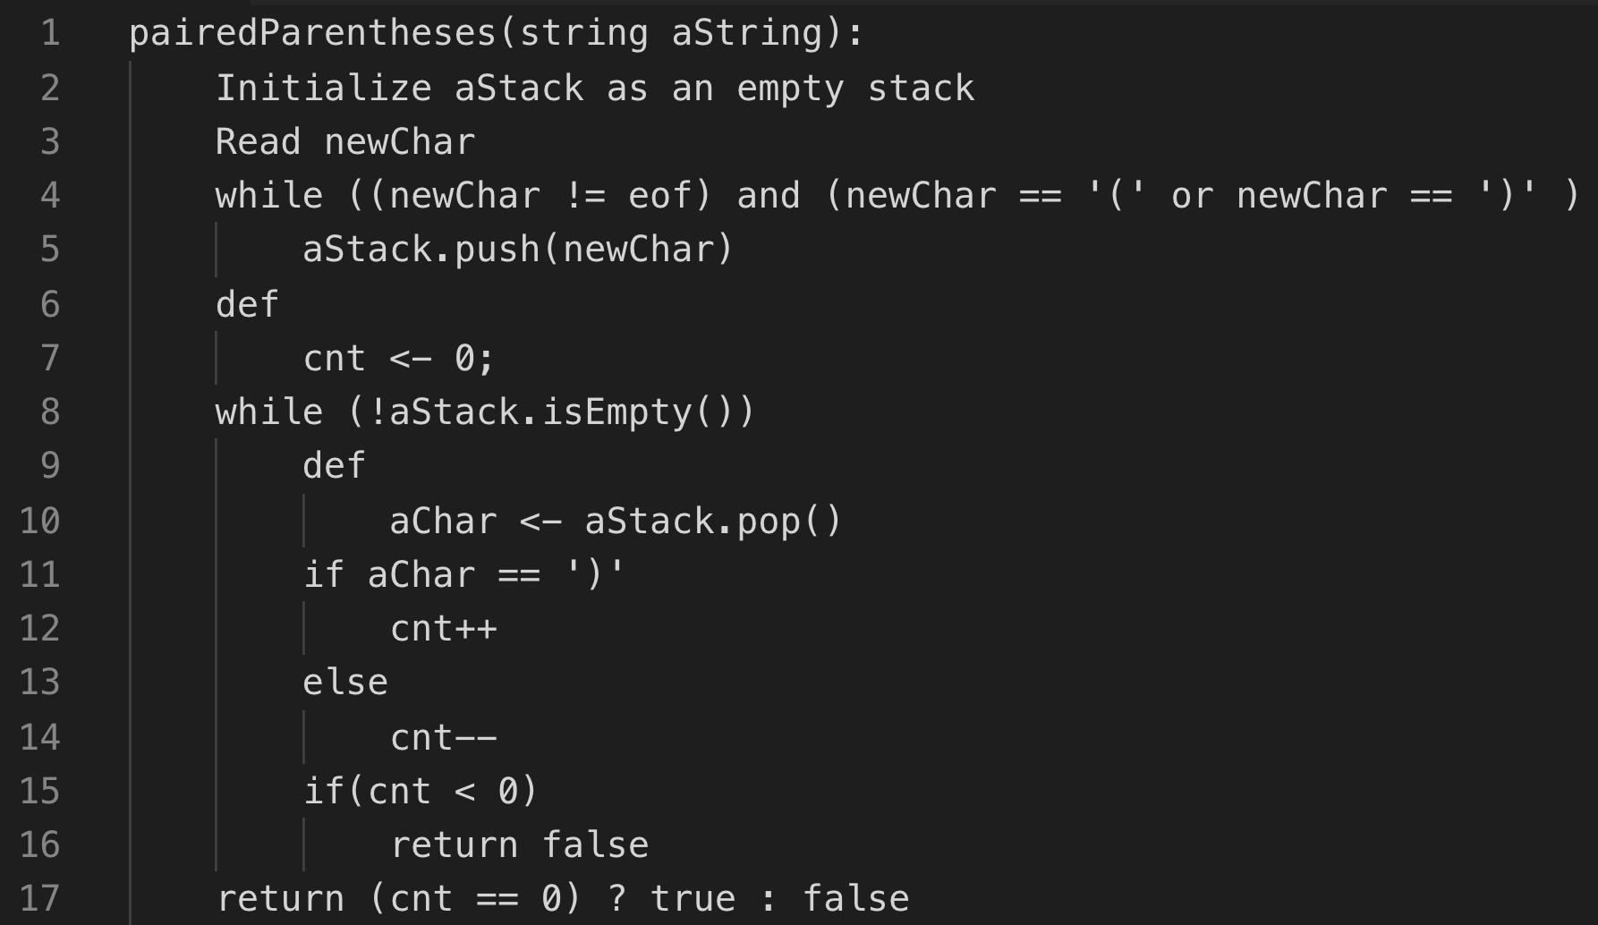

1. A bottom-up printer



1. A bottom-up printer as a member function



1. Binomial Coefficient

